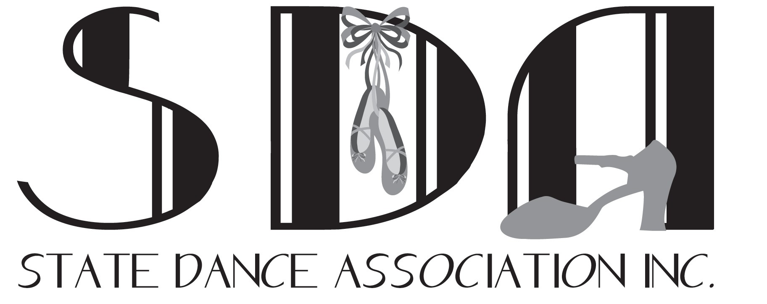

SDA MEMBERSHIP REQUIREMENTS & POLICY:
To become an SDA member the following is required.
- Attend 2 out of 3 meetings per year or send a school representative in your place
- Promptly update contact details if they change
- Represent the SDA in a professional manner at all times
- Adhere to all state & national legislation regarding child safety and registrations
- Complete and sign the SDA code of conduct and child safe document
- Obtain adequate insurance
- Ensure that all fees are paid by the due dates
- Participate in & assist at SDA events if in attendance

NEW MEMBER: $250.00 PER STYLE (Ballet, Jazz & Tap) to a MAXIMUM of $550.00
All new members to the State Dance Association. After the first year the continuing membership rate applies
- Financial Member- can vote and attend meetings
- Receives SDA Handbook
- Receives ordered syllabi, music and DVD ($250 per style to a MAXIMUM of $550)
- “New member” is for the first year of your membership only
- Receives meeting invites and minutes
- Can access online members page and documents
- Can teach the syllabus & submit formal examinations
- Website directory listing
- SDA Membership card (as requested)
​CONTINUING MEMBERSHIP: $175.00 PER ANNUM
An active participating & annually continuing member of the State Dance Association
- Financial Member- can vote and attend meetings
- Receives meeting invites & minutes
- Receives SDA Handbook when a new version is released
- Can access online members page and documents
- Can teach the syllabus & submit formal examinations
- Website directory listing
- SDA Membership card (as requested)
﻿

- SDA Membership card
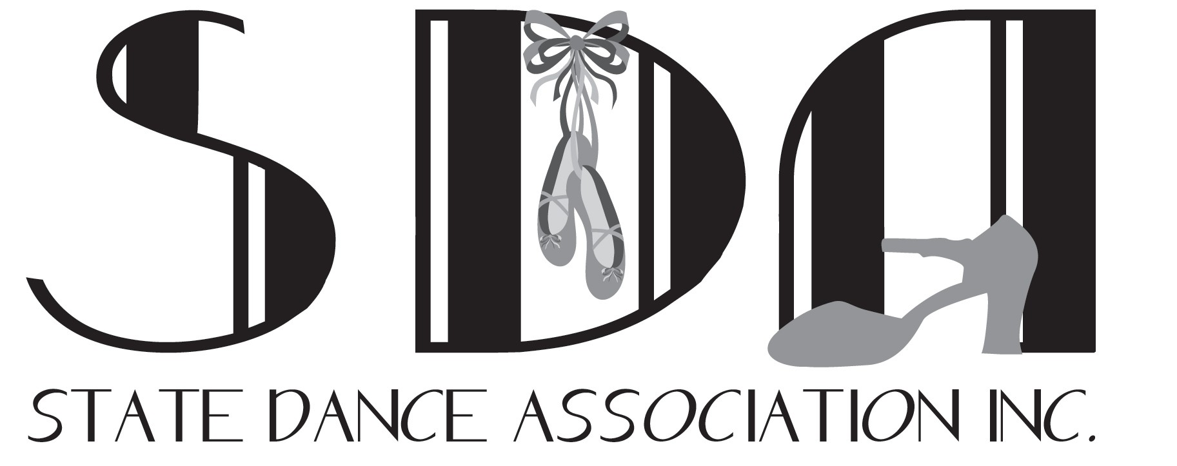

NEW MEMBERSHIP APPLICATION

APPLICANT FULL NAME: DATE:

- Applicants Residential Address:

Post Code:

Applicants Postal Address (if different):

Post Code:

- Name of Dance Studio/s you teach at & the Suburb:

_____________________________________________________________

- Applicant Phone: Mobile: BH:

- Email:

- Where did you hear about the State Dance Association Inc.
______________________________________________________________________________

- Your dance qualifications or explanation of dance teaching experience:
(Please include all previous/current & other syllabus taught if applicable and attach proof of qualifications & letter of professional recognition if applicable)

- Are you a Studio Principal?: YES / NO

NEW MEMBERSHIP APPLICATION Continued…..

IT IS A REQUIREMENT OF SDA TO HAVE ADEQUATE INSURANCE AND WWC CHECKS

- INSURANCE COMPANY, CURRENT POLICY NO. & EXPIRY DATE

- WORKING WITH CHILDREN’S CHECK or TEACHING NUMBER & EXPIRY DATE
Please attached a copy or email a copy

- Do you hold a current First Aid CPR Certificate? YES/NO

- Please forward this membership application along with direct deposit receipt, for Membership Fees to-
statedanceassociation@live.com or SDA, 56 Ashwood Drive, Ashwood, VIC 3147

PAYMENT OPTION:
BANK TRANSFER-
Account Name: STATE DANCE ASSOCIATION
BSB- 063 885
Account Number- 1034 1634 (Use School Name as ref & notify the Treasurer of payment)

I hereby agree to abide by the policies and guidelines as set out by the STATE DANCE ASSOCIATION INC.

/ /

signature date

----------------------------------------------------------------------------------------------------------------------------------------

OFFICE USE ONLY

Treasurer Received: $
  - Details sent to Member List Coordinator
  - Advised requirements of Syllabus & Music
  - Signed COC and Child Safe Policy filed
Receipt #

JAZZ, TAP, CLASSICAL: Sent on: / / ____
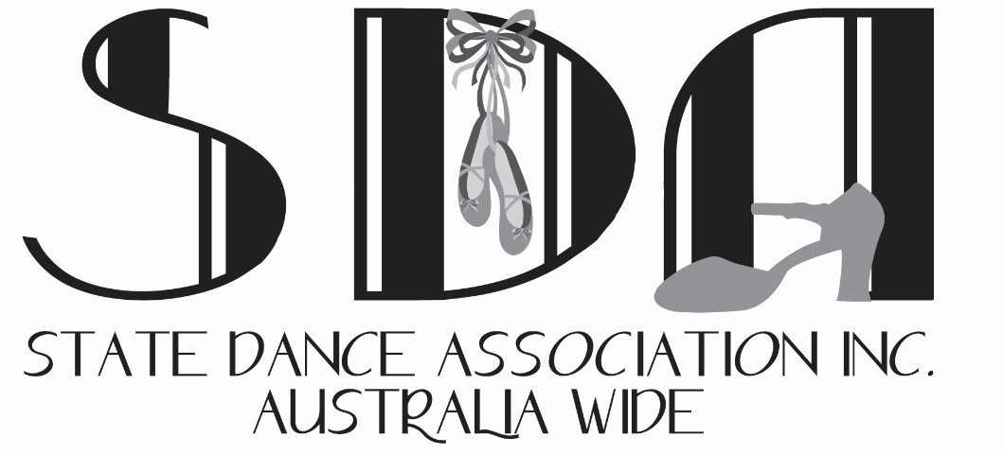

SDA CHILD SAFE POLICY

Under the Child Safety and Wellbeing Act, Victorian organisations that provide services to children are required to implement compulsory child safe standards to protect children from harm.
​
The State Dance Association Inc. has written a Child Safe Policy to demonstrate the strong commitment of the association to child safety and the policies and practices developed to keep everyone safe from any harm, including abuse.

The State Dance Association Inc. is a membership-based association for dance teachers across Australia. Our members are required to hold a valid working with children card (WWCC). Although the association does not directly teach children, our syllabi is used as a teaching resource and our events are child focused; hence, this policy is in place.
​
This document demonstrates the State Dance Association Inc. is compliant with Child Safe Policies & procedures. For more information, see A Guide for Creating a Child-safe Organisation produced by the Commission for Children and Young People (CCYP) available at www.ccyp.vic.gov.au
​

Commitment to child safety
The State Dance Association Inc. is a Child Safe organisation. As an association, we are committed to and focused on promoting and providing a safe community for all students and family members at all times. We want all students to feel safe, supported, respected, happy, empowered and have fun at all SDA events.
The welfare of the children will always be our first priority and we have a zero tolerance to child abuse. This policy effective 01/01/2018 demonstrates the strong commitment of the State Dance Association Inc. to child safety and provides the policies and practices developed to keep everyone safe from any harm, including abuse. It applies to all members, children and individuals involved in our association
​

Children’s rights to safety and participation
The State Dance Association Inc. encourage children to express their views. We listen to their suggestions, especially on matters that directly affect them. We actively encourage all children to ‘have a say’ about things that are important to them.
We listen to and act on any concerns children, or their parents/carers, raise with us.

Valuing diversity
We value diversity and do not tolerate any discriminatory practices. To achieve this we:
• promote the cultural safety, participation and empowerment of Aboriginal children and their families
• promote the cultural safety, participation and empowerment of children from culturally and/or linguistically diverse backgrounds and their families
• welcome children with a disability and their families and act to promote their participation
• seek appropriate staff from diverse cultural backgrounds.
• support diversity, equity and inclusion

​

SDA Member CODE OF CONDUCT

Our member’s commitment to child safety
All of our State Dance Association Inc. members understand our child safety policy and are as passionate about providing a safe and fun environment for all students, where each and every student feels supported and empowered. See our Member Code Of Conduct below.
State Dance Association Inc. applies the best practice standards in the recruitment and screening of members. We have compulsory criteria that must be met in order to gain or renew membership.

Member Code of Conduct​
This Code of Conduct outlines appropriate standards of behaviour by adults towards children. The Code of Conduct aims to protect children and reduce any opportunities for abuse or harm to occur. It also helps members and volunteers by providing them with guidance on how to best support children and how to avoid or better manage difficult situations. All members & volunteers are required to comply.
​
All State Dance Association Inc. members and volunteers are responsible for promoting the safety and wellbeing of children and young people by:
• adhering to our Child Safe Policy, and other policies
• taking all reasonable steps to protect children from abuse
• treating everyone with respect, including listening to and valuing their ideas and opinions
• welcoming all children and their families and carers and being inclusive
• respecting cultural, religious and political differences and acting in a culturally sensitive way
• modelling appropriate adult behaviour
• listening to children and responding to them appropriately
• reporting and acting on any breaches of this Code of Conduct, complaints or concerns
• complying with our guidelines on physical contact with children
• Working with children in an open and transparent way – other adults should always know about the work you are doing with children
• respecting the privacy of children and their families, and only disclosing information to people who have a need to know.
​State Dance Association Inc. members and volunteers must NOT:
• seek to use children in any way to meet the needs of adults
• ignore or disregard any concerns, suspicions or disclosures of child abuse
• use prejudice, oppressive behaviour or language with children
• engage in rough physical games
• discriminate on the basis of age, gender, race, culture, vulnerability or sexuality
• initiate unnecessary physical contact with children or do things of a personal nature that children can do for themselves, such as toileting or changing clothes
• develop ‘special’ relationships with specific children or show favouritism through the provision of gifts or inappropriate attention
• exchange personal contact details such as phone number, social networking site or email addresses with children
• have unauthorised contact with children and young people online or by phone.
​
As part of the screening membership application/renewal process, an applicant must provide State Dance Association Inc. appropriate evidence to show that they are suitable to work with children and young people in a safe dance environment. This includes:
• Working with children's check (WWCC)
• Appropriate / high level of dance experience
• Appropriate dance teaching experience

Member Responsibilities
• Always treat other members with respect & professionalism
• Respect the privacy of other members and students
• Do not discriminate against any students, no matter their background or experience.
• Do not poach students from other studios
• Always provide a supportive and safe environment for all students.
• Do not develop any ‘special’ relationships with children that could be seen as favouritism (for example, the offering of gifts or special treatment for specific children).
• Do not put children at risk of abuse or ignore or disregard any suspected or disclosed child abuse. (Please read our Child Safety Policy)
• Respond professionally and efficiently to any parent concerns
• Do not do things of a personal nature that a child can do for themselves, such as toileting or changing clothes.
• Do not engage in open discussions of a mature or adult nature in the presence of children (for example, personal social activities).
• Do not use inappropriate language or music in the presence of children
• Do not express personal views on cultures, race or sexuality in the presence of children
• Do not discriminate against any child, including but not limited to: because of culture, race, ethnicity or disability.
• Conduct yourself in a professional manner at all times
• Always empower and encourage students to be the best they can be

I have read this Code of Conduct in its entirety and agree to abide by it at all times.
​
Print Name _________________________________________________

Signed _______________________________ Date ___________

CONCERN OR COMPLAINT PROCEEDURE

Reporting a child safety concern or complaint
State Dance Association Inc. members, children and families are supported to raise any concerns or complaints regarding any risks to a child's safety or any signs of abuse.
All concerns or complaints should be made in writing to State Dance Association Inc.
statedanceassociation@gmail.com
Support will be offered to all people involved.
Please remember that if you believe a child is at immediate risk to call 000 as soon as possible.
​
Reviewing this policy​
This policy will be reviewed every two years and we undertake to seek views, comments and suggestions.

